GAS LEAKAGE MONITORING SYSTEM

Team members:

Shanmugam.S-1919102142

Vigneashwaran.B-1919102182

Vishnu V-1919102192

Thirumurugan.M-1919102173

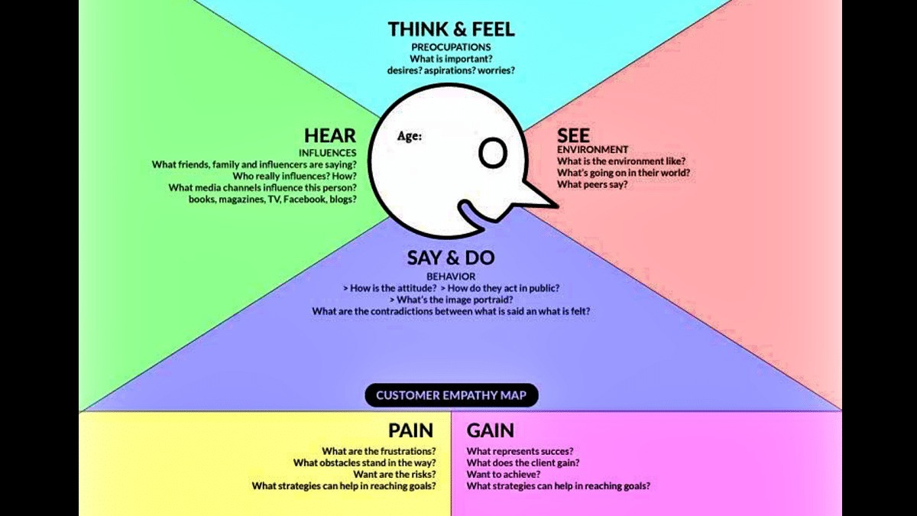



Description:

Access the courses and learning resources in steps.

To learn about the foundations of Agile Methodologies and specific technologies, refer to the self-paced learning course that is offered under the courses area.

Refer to the technical articles under the learning resources page for further information on the abilities necessary for the project you have signed up for.

Attend the live, hands-on technical training as the second step.

Attend the live, hands-on training sessions to begin your technology-specific instruction from scratch and get a solid understanding of the ideas that will assist you while you work on the guided project.

Access the Guided Project at step three.

By clicking the go-to workspace button, you can access the guided project that is displayed under the guided project tab. By doing this, the guided